Risk Assessment for: Fire Lighting | Establishment: 4Th Canvey Island Sea Scout Group | Date Created: 13/09/2020
Risk Assessment by: Jake Francis | Approved by: Tania Powell | Date Reviewed: 13/09/2020  Next Review: 09/2021
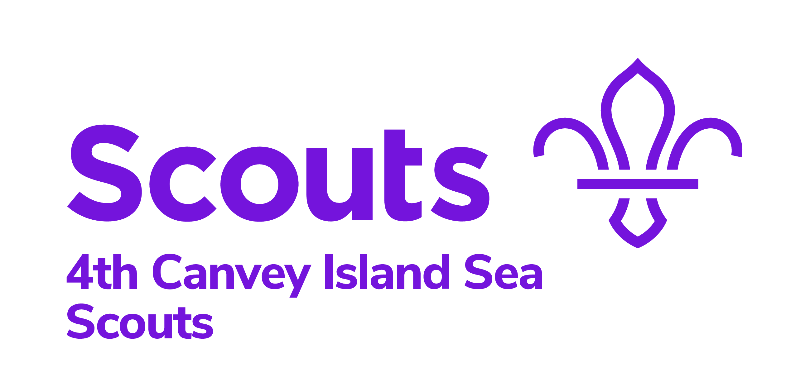

HIGH RISK
MEDIUM RISK
LOW RISK
Risks/Hazards Identified: | Who is at risk: | Control Measures in place: | What has changed that needs to be thought about and controlled? | Risk Level:
Slips, trips, falls:  Could suffer injury e.g. sprains and fractures if they trip and fall | All | - Work areas should be kept clear of obstructions.  - All areas should be well lit.  - First Aider to be on-site
Fire  Burns, Fire spreading | All | - Safety briefing at the start.  - Fire buckets to put the fire out and can also be used if someone has a burn.  - First aid bag close by.  - Fires to always be supervised.
Flint and steel  Burns, cuts | All | - Safety briefing at the start.  - Instructed fully on how to use the flint and steels by a Leader.  - Supervised at all times.
Woodpile  Nails, Splinters | All | - Safety briefing and rules to be done before collecting wood.  - First aider with each group.

